**Pizza Sales SQL Queries**

**Over – Viewing the data**

SELECT * FROM pizza_sales

**KPI’s Requirement**

**1.Total Revenue**

SELECT CAST(SUM(total_price) AS decimal(10,2)) AS Total_Revenue FROM pizza_sales

**Output:**

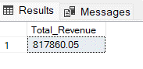

**2. Average Order Value**

SELECT CAST(SUM(total_price) / COUNT(DISTINCT order_id) AS DECIMAL(10,2)) AS average_order_value FROM Pizza_sales

**Output:**

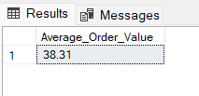

**3. Total Pizzas Sold**

SELECT SUM(quantity) AS Total_Pizzas_Sold FROM Pizza_sales

**Output:**

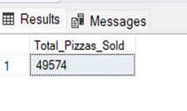

**4. Total Orders**

SELECT COUNT(DISTINCT order_id) AS Total_Orders FROM Pizza_sales

**Output:**

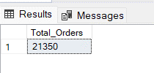

**5. Average pizzas per order**

SELECT CAST(CAST(SUM(quantity) AS DECIMAL(10,2)) / CAST(COUNT(DISTINCT order_id) AS DECIMAL(10,2)) AS DECIMAL(10,2)) AS Average_pizzas_Per_Order FROM Pizza_sales

**Output:**

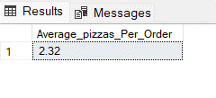

**Business Insights Report:**

**1. Daily Trend for Total Orders**

SELECT DATENAME(DW, order_date) AS Day, COUNT(DISTINCT order_id) AS Total_Orders FROM Pizza_sales

GROUP BY DATENAME(DW, order_date), DATEPART(DW, order_date)ORDER BY DATEPART(DW, order_date)

**Output:**

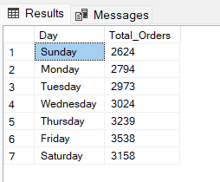

**2. Monthly Trend for Total Orders**

SELECT DATENAME(MONTH, order_date) AS MONTH, COUNT(DISTINCT order_id) AS Total_Orders FROM Pizza_sales

GROUP BY DATENAME(MONTH, order_date), DATEPART(MONTH, order_date)

ORDER BY DATEPART(MONTH, order_date)

**Output:**

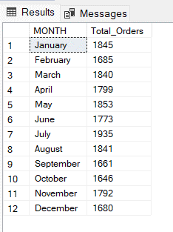

**3. Percentage of Sales by Pizza Category**

SELECT pizza_category AS Pizza_Category, CAST(SUM(total_price) AS DECIMAL(10,2)) AS Total_Sales,

CAST(SUM(total_price) * 100 /

(SELECT SUM(total_price) FROM Pizza_sales) AS DECIMAL(10,2)) AS Percentage_of_Sales FROM Pizza_sales

GROUP BY Pizza_category

ORDER BY Percentage_of_Sales

**Output:**

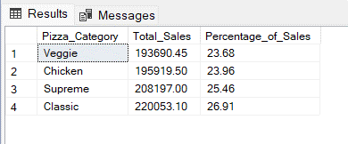

**4. percentage of Sales by Pizza Size**

SELECT pizza_size AS Pizza_Size, CAST(SUM(total_price) AS DECIMAL (10,2)) AS Total_Sales,

CAST(SUM(total_price) * 100 /

(SELECT SUM(total_price) FROM Pizza_sales) AS DECIMAL(10,2)) AS percentage_of_Sales FROM pizza_sales

GROUP BY pizza_size

ORDER BY percentage_of_Sales DESC

**Output:**

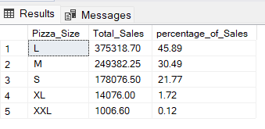

**5. Total Pizzas Sold by Pizzas Category**

SELECT pizza_category AS Pizza_Category, SUM(quantity) AS Total_Pizza_Sold FROM pizza_sales

GROUP BY Pizza_Category

Order BY Total_Pizza_Sold DESC

**Output:**

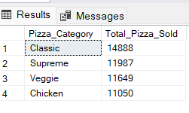

**6. Top 5 pizzas by Total Revenue**

SELECt top 5 pizza_name AS Pizza_Name, CAST(SUM(total_price) AS DECIMAL(10,2)) AS Total_Revenue

FROM pizza_sales

GROUP BY Pizza_Name

ORDER BY Total_Revenue DESC

**Output:**

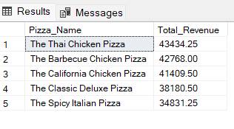

**Top 5 Pizza by Total Quantity**

SELECT Top 5 pizza_name as Pizza_Name, SUM(quantity) AS Total_Quantity

FROM pizza_sales

GROUP BY Pizza_Name

ORDER BY Total_Quantity DESC

**Output:**

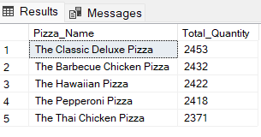

**Top 5 Pizzas by Total Orders**

SELECT Top 5 pizza_name as Pizza_Name, COUNT(DISTINCT order_id) as Total_Orders FROM Pizza_sales

GROUP BY pizza_name

ORDER BY Total_Orders DESC

**Output:**

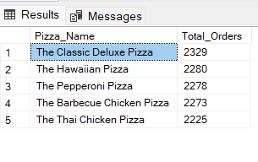

**7. Bottom 5 Pizzas by Total Revenue**

SELECT Top 5 pizza_name as Pizza_Name , CAST(SUM(total_price) AS DECIMAL(10,2)) AS Total_Revenue FROM pizza_sales

GROUP BY pizza_name

ORDER BY Total_Revenue

**Output:**

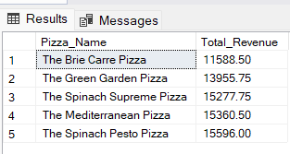

**Bottom 5 Pizzas by Total Quantity**

SELECT Top 5 pizza_name as Pizza_Name , SUM(quantity) AS Total_Quantity FROM pizza_sales

GROUP BY pizza_name

ORDER BY Total_Quantity

**Output:**

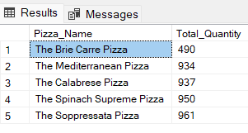

**Bottom 5 Pizzas by Total Orders**

SELECT Top 5 pizza_name as Pizza_Name , COUNT(DISTINCT(order_id)) AS Total_Orders FROM pizza_sales

GROUP BY pizza_name

ORDER BY Total_Orders

**Output:**

